Product category: AC DRIVES (VFD’s)

AC DRIVE COMPANY

ABB

1. Model name: ABB-**ACS** SERIES AC DRIVE

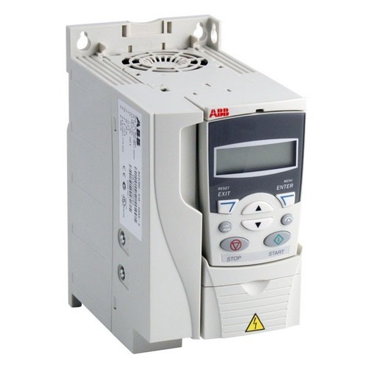

1. **MODEL NAME : ABB - ACH SERIES AC DRIVE**

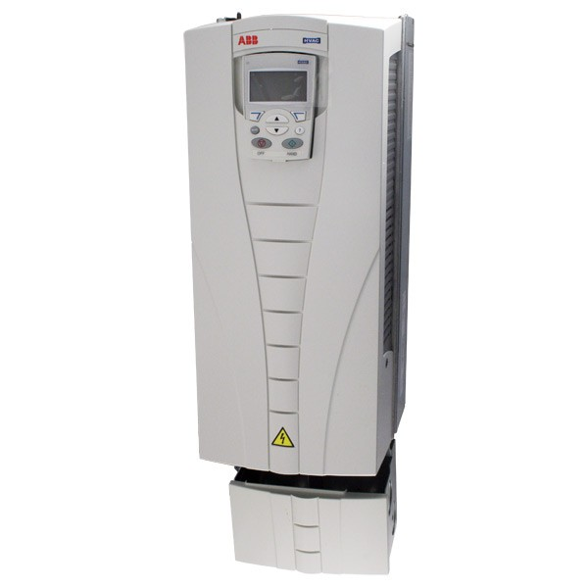

1. MODEL NAME: ABB-ACQ AC DRIVE

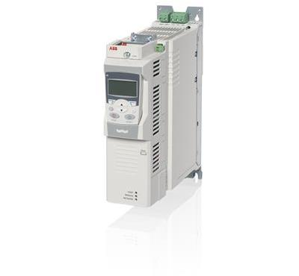

MODEL NAME: ABB- ACL SERIES AC DRIVE

[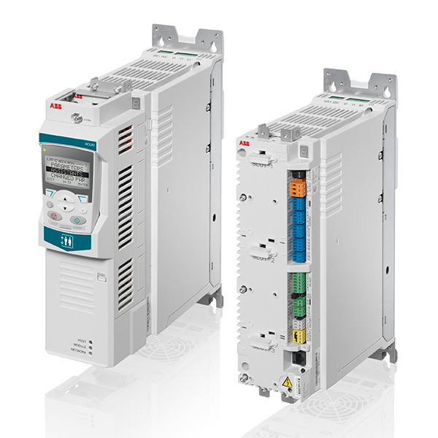](https://www.deltaelectronicsindia.com/industrial-automation/touch-panel-hmi-human-machine-interfaces/tp70p/" \o "TP70P)

MODEL NAME: ALL OTHER ABB AC DRIVES

